

|  |
| --- |
| *BS Cyber Security Department AU* |

|  |  |
| --- | --- |
| **Registration ID** | **233026** |
| **Submitted By** | **Muhammad Sohaib Rafiq** |
| **Submitted To** | **Iram Fatima Hashmi** |
| **Date of Submission** | **05/29/2025** |
| **Lab NO.** | **9** |
| **Subject** | **NS LAB** |

**pfSense:**

➢ The pfSense project is a free network firewall distribution, based on the FreeBSD operating

system with a custom kernel and including third party free software packages for additional

functionality.

➢ pfSense software includes a web interface for the configuration of all included components.

There is no need for any UNIX knowledge, no need to use the command line for anything,

and no need to ever manually edit any rule sets.

➢ Users familiar with commercial firewalls catch on to the web interface quickly, though

there can be a learning curve for users not familiar with commercial-grade firewalls.

**Installation and configuration:**

➢ Follow following links for installation and setup:

o https://docs.netgate.com/pfsense/en/latest/install/install-walkthrough.html

o https://www.youtube.com/watch?v=Y-Dj8lHmXy8

➢ After you are done installing, you would see an interface like below listing your WAN and

LAN interface (the two network adapters you have set in start).

**PfSense setting of LANS and WANS:**

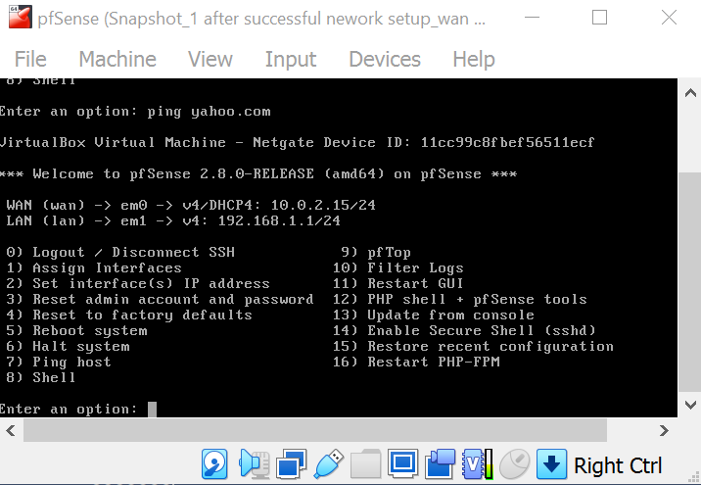

**After installation:**

The after installing, you can use its console interface for basic network setup,

troubleshooting, reset admin password, reboot, halt system etc

➢ The web interface is accessible at LAN interface using default credentials (admin:pfsense)

you have setup on any other VM on internal network.

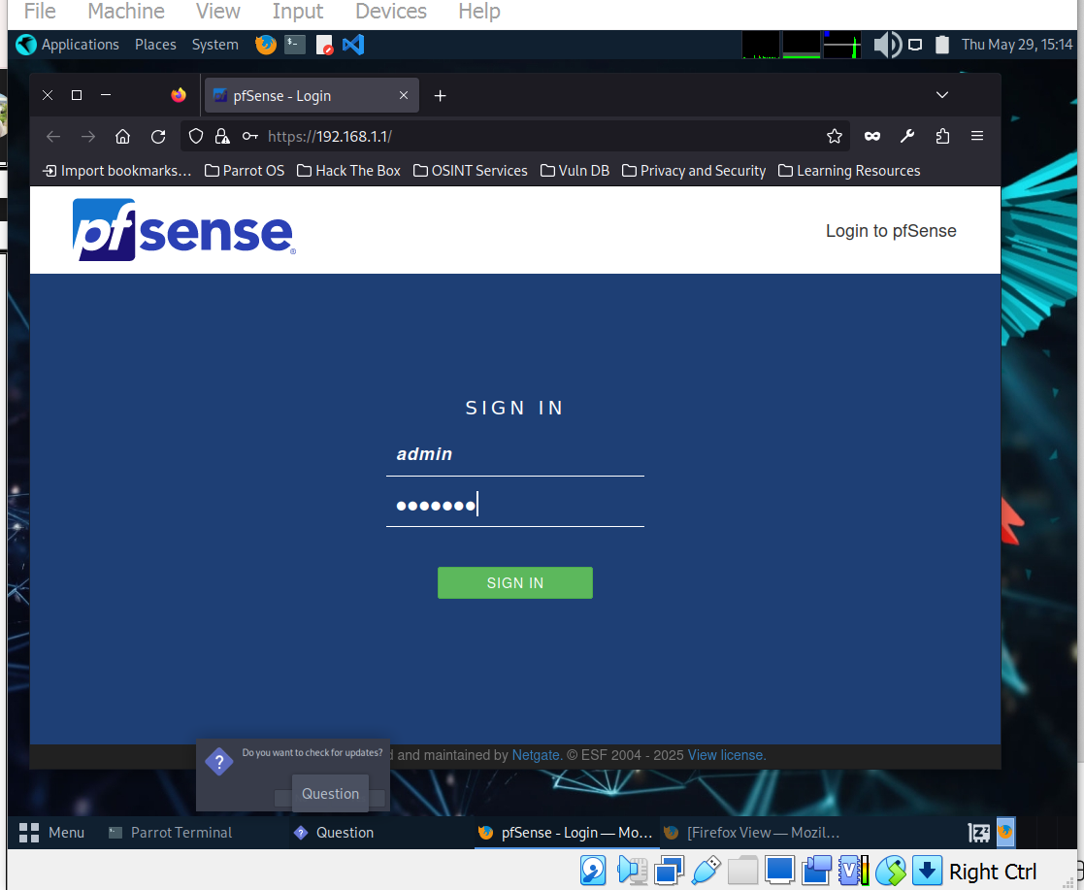

**Tasks;**

1. **Setup pfSense and Access Web GUI**

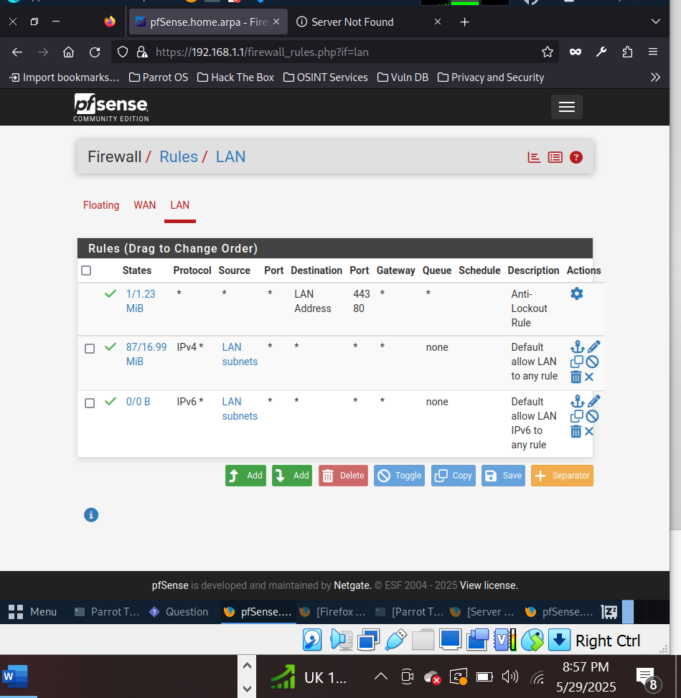

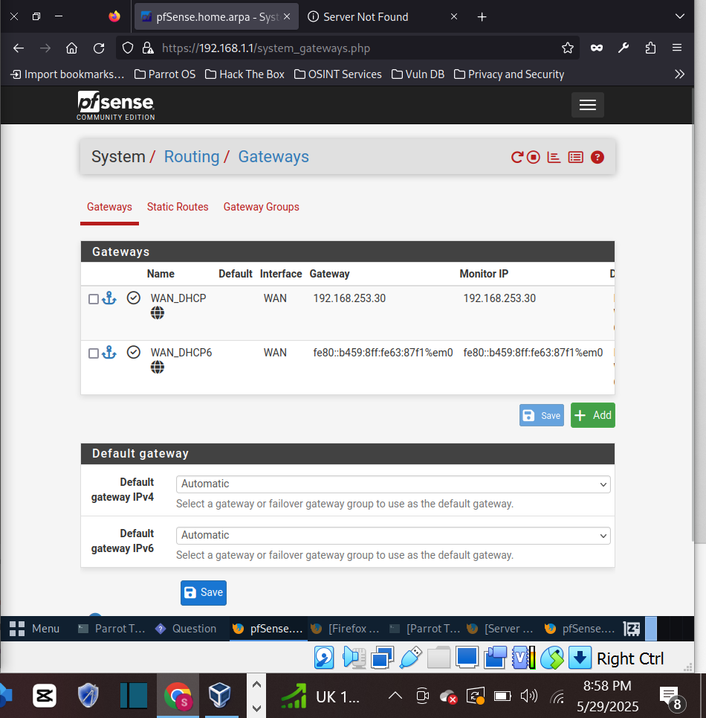

1. **Test Internet Access on Client VM on Internal Network**

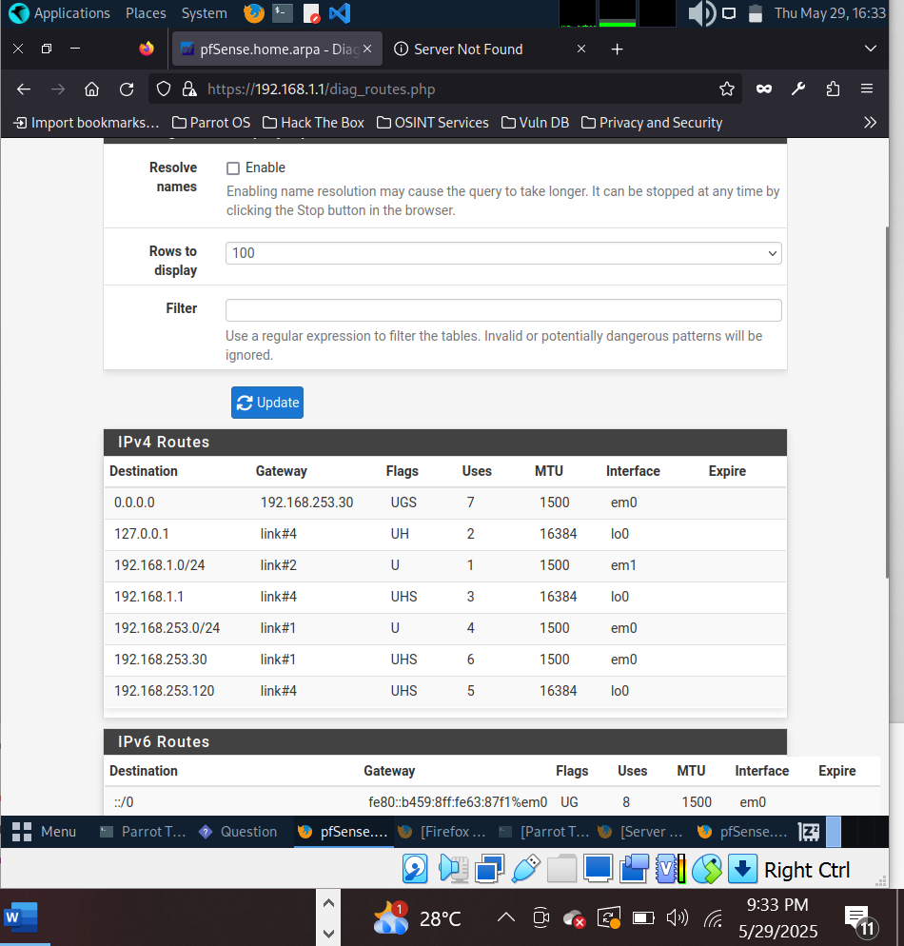

**Before blocking:**

**Youtube, Facebook and Instagram are accessible on client:**

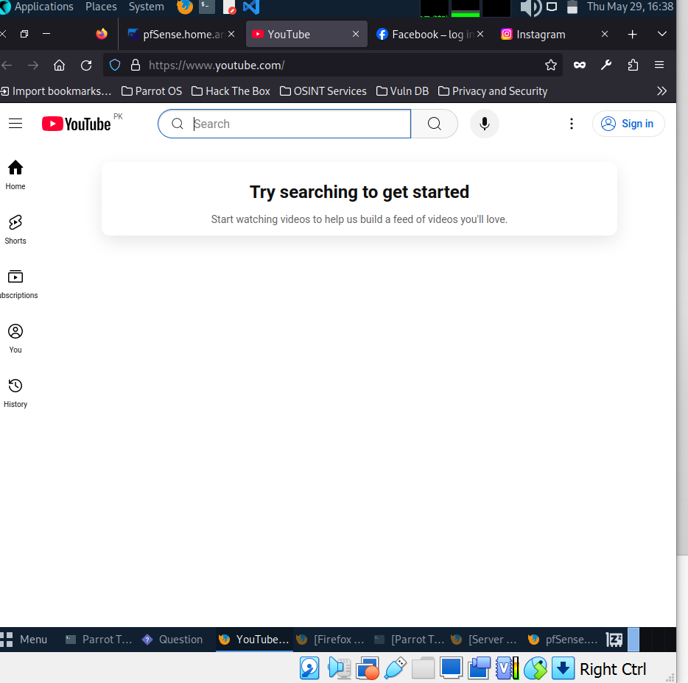

**Facebook:**

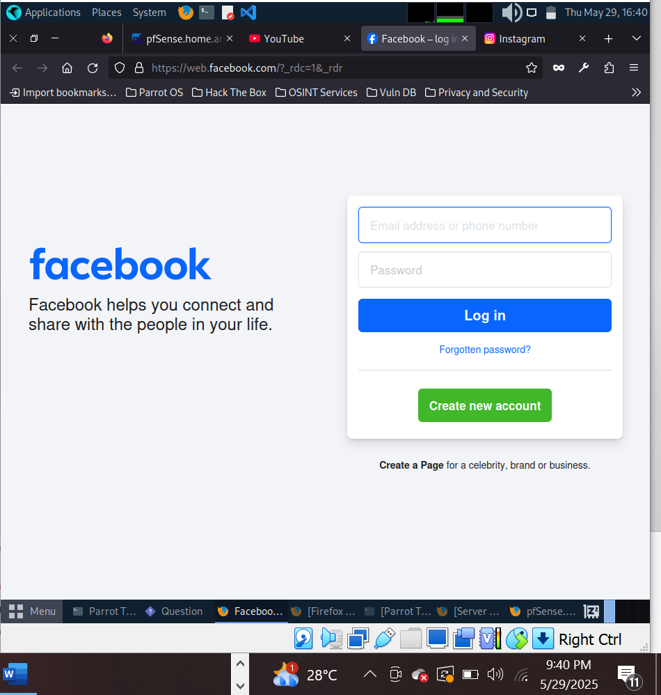

**Instagram:**

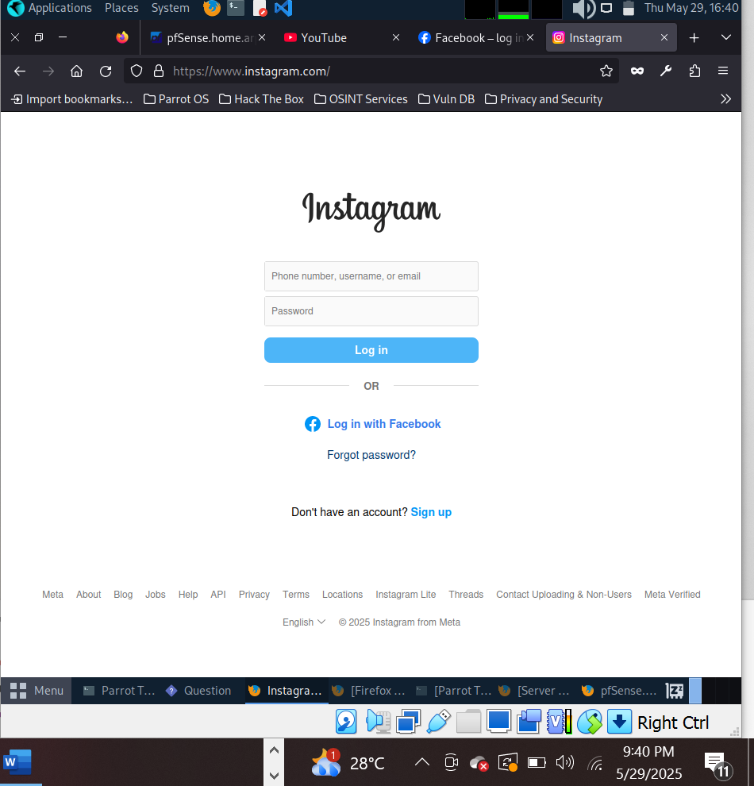

**o Add firewall rules to block facebook, Instagram and youtube.**

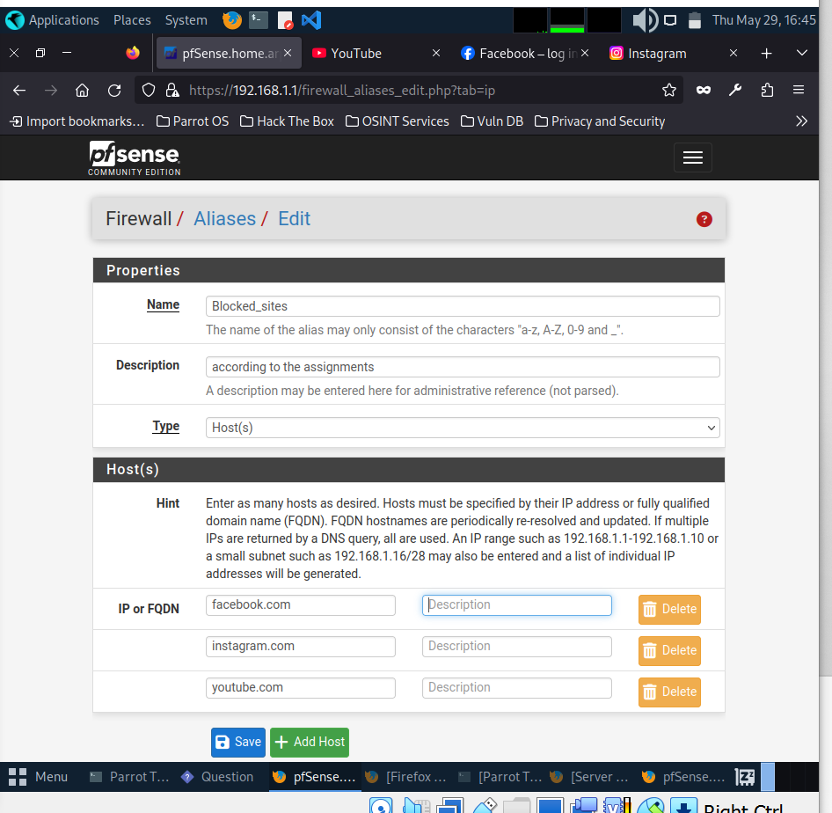

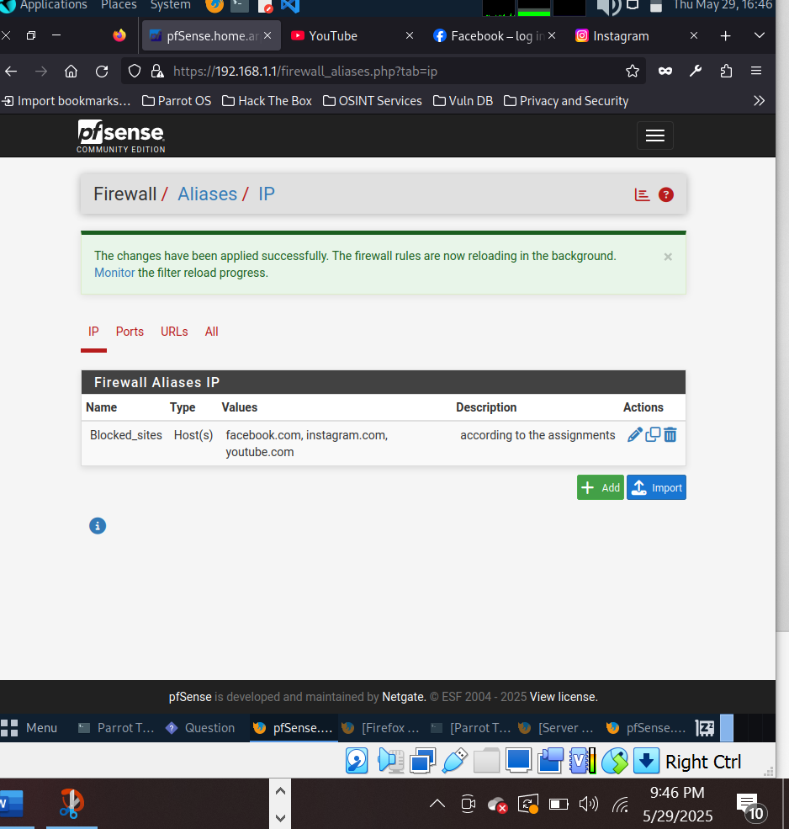

**After setting the rules now accessing the websites:**

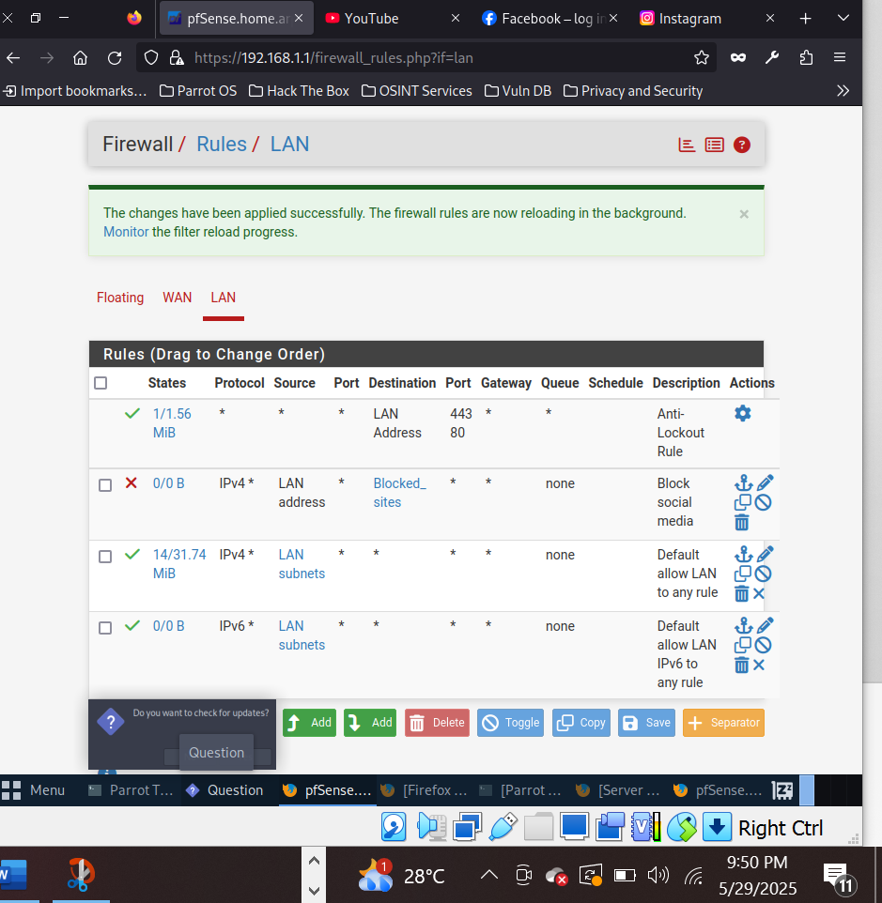

**Results:**

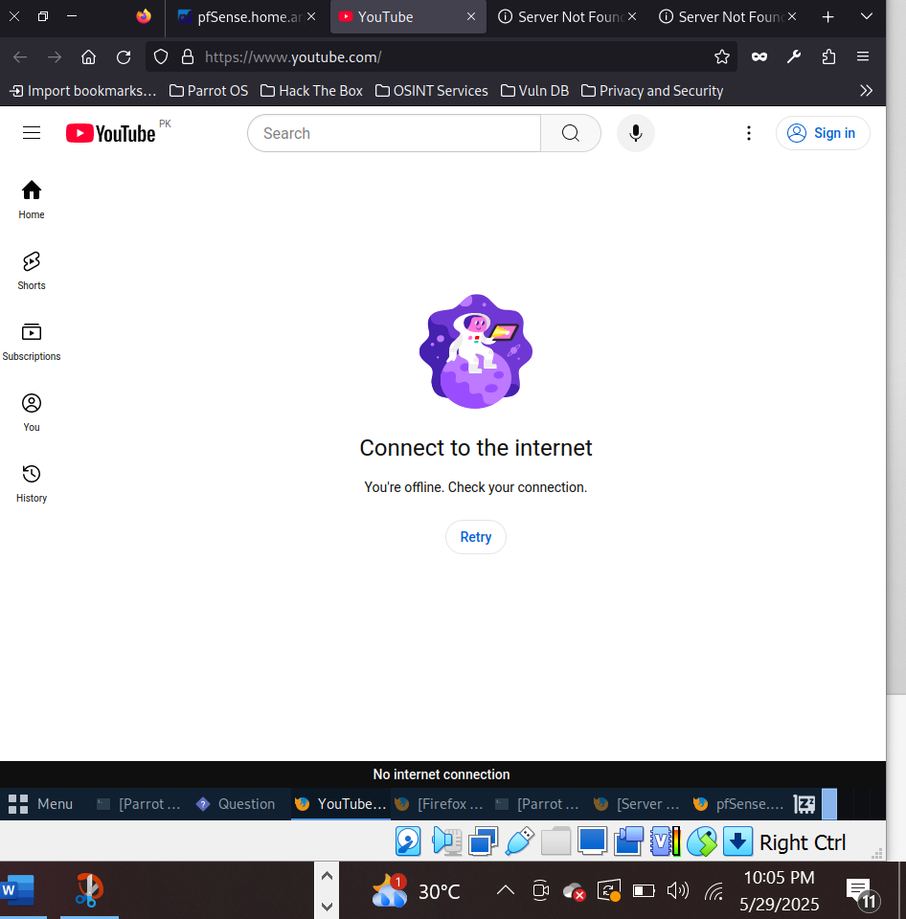

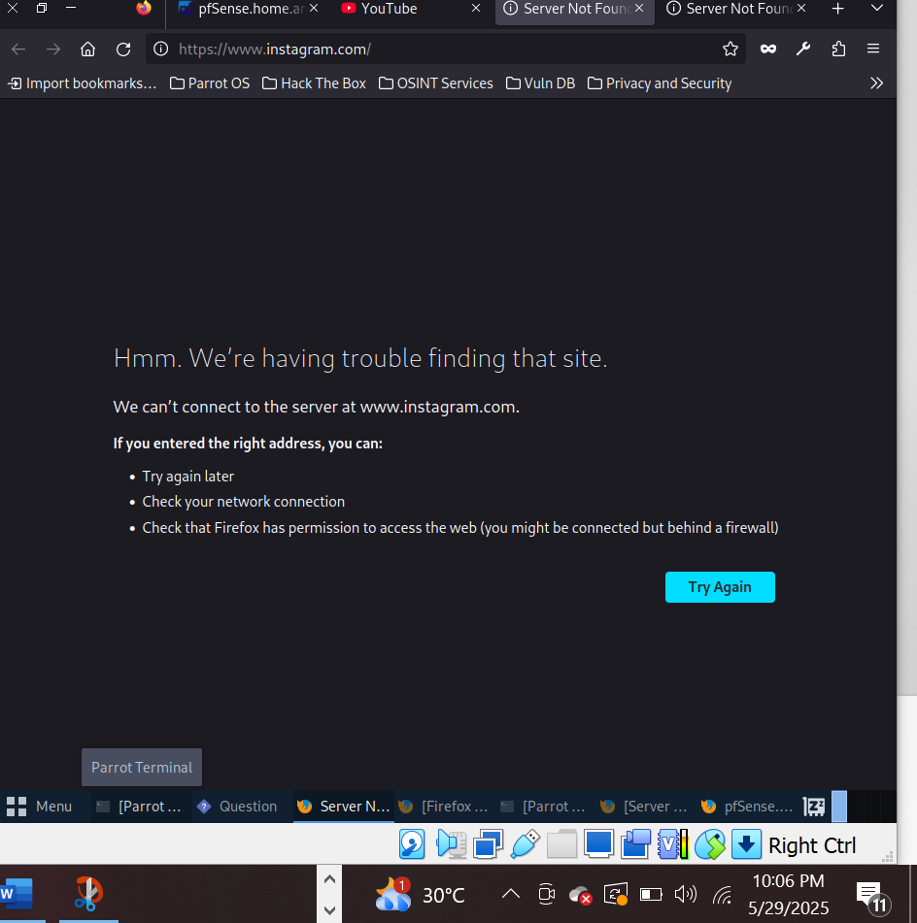

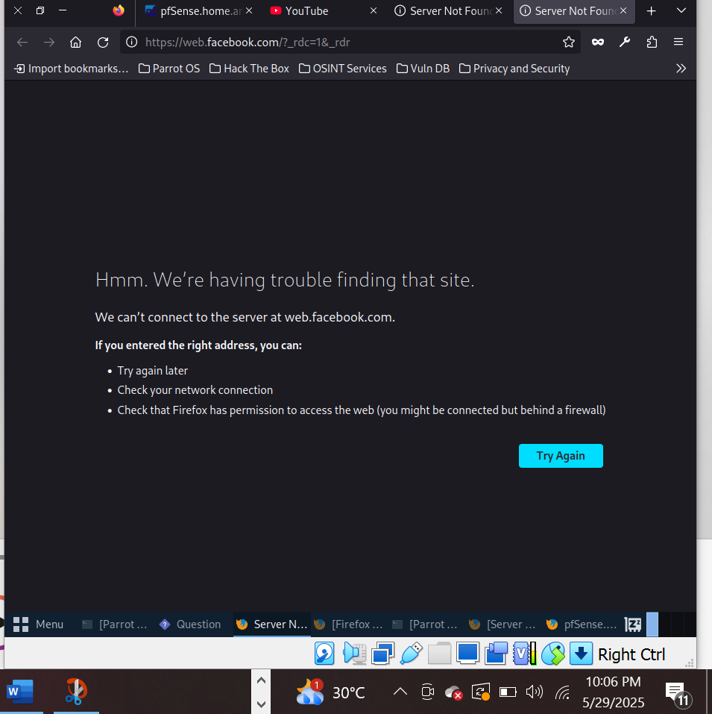

**Monitoring the Traffic:**

